ITA0502-COMPUTER VISION
C01 AT-2
CONCEPT MAPPING

Name: Y.Thanushma
Registration Number: 192425355

1.Construct a comprehensive and well-organized concept map illustrating the complete
pipeline from real-world scene capture to digital image representation. Identify all major
concepts, establish meaningful relationships among intermediate transformations and
dependencies, integrate insights from at least five recent literature sources, and present
the map with clear hierarchy, linking phrases, and logical organization.

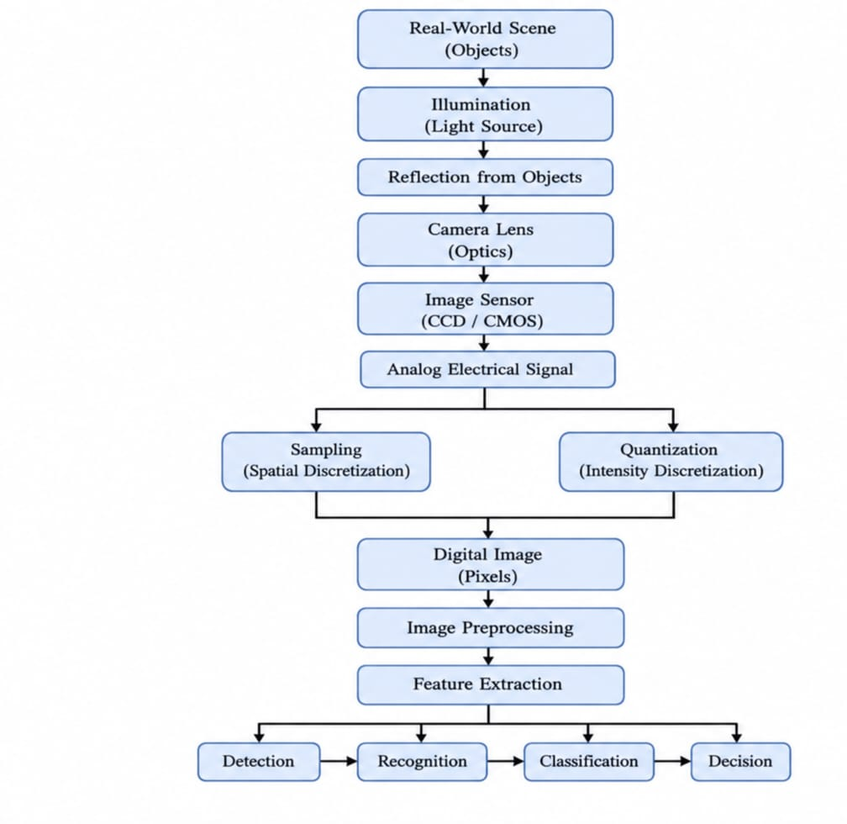

Category | Description
Relationship | A real-world scene is captured through illumination and reflection. The camera converts it into a digital image for Computer Vision applications.
Image Formation Process | Light → Reflection → Camera Lens → Image Sensor → Analog Signal → Sampling → Quantization → Digital Image
Image Processing | The digital image undergoes preprocessing and feature extraction before analysis.
Final Output | Detection, Recognition, Classification, and Decision-making.
Applications | Medical Imaging, Face Recognition, Surveillance, Autonomous Vehicles.
Literature Findings | • CMOS sensors improve image acquisition.• Sampling determines spatial resolution.• Quantization determines intensity resolution.• Image preprocessing removes noise and enhances quality.• Feature extraction improves object recognition accuracy.

2.Develop a hierarchically structured concept map illustrating the major stages of visual
data handling in a Computer Vision system. Clearly show the relationships among
acquisition, preprocessing, feature extraction, analysis, and interpretation stages,
explain their contributions to meaningful outputs, incorporate findings from at least five
literature sources, and ensure clarity and readability.
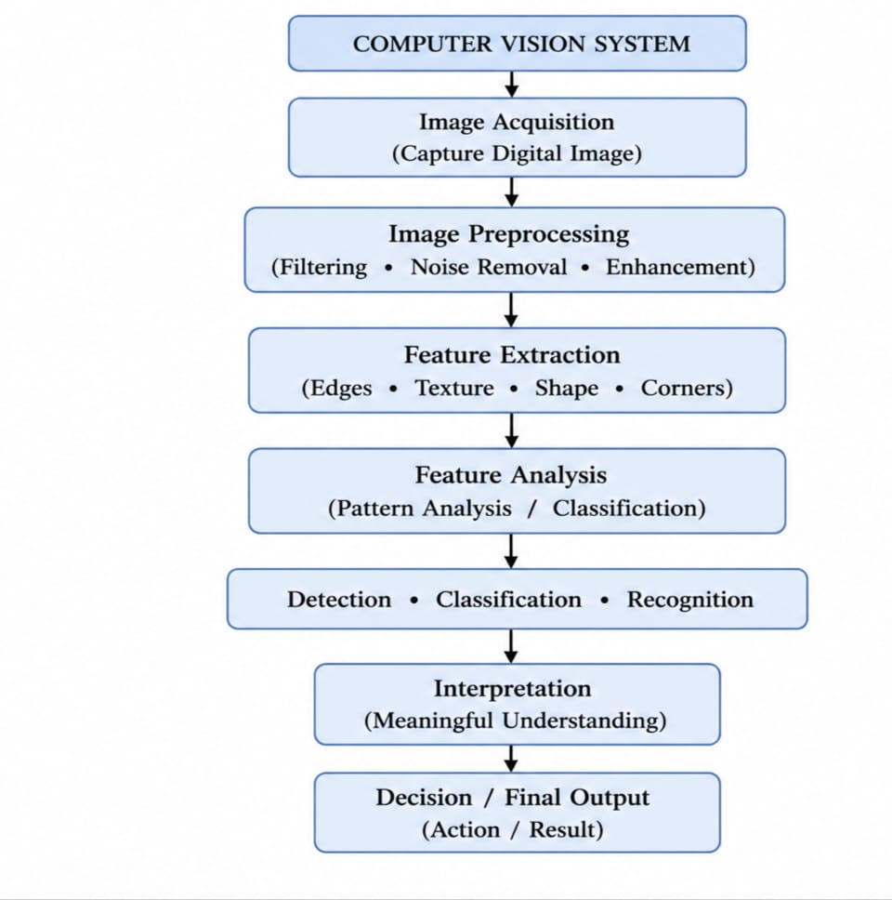
Contributions of Each Stage
- Image Acquisition: Captures the digital image.
- Image Preprocessing: Removes noise and enhances quality.
- Feature Extraction: Extracts edges, textures, shapes, and corners.
- Feature Analysis: Detects, classifies, and recognizes objects.
- Interpretation: Converts analysis into meaningful understanding.
- Decision: Produces the final output or action.
Applications
- Object Detection
- Face Recognition
- Medical Diagnosis
- Industrial Inspection
Literature Findings
- Preprocessing improves recognition accuracy.
- Feature extraction reduces computational complexity.
- Deep learning improves classification performance.
- High-quality images increase analysis accuracy.
- Computer Vision enables intelligent automation.

3.Create a detailed concept map explaining the relationships among image resolution,
spatial resolution, intensity resolution, and image quality. Clearly illustrate cause-and-
effect relationships, discuss their impact on image usability in different applications,
integrate evidence from at least five research articles, and organize the concepts
logically.
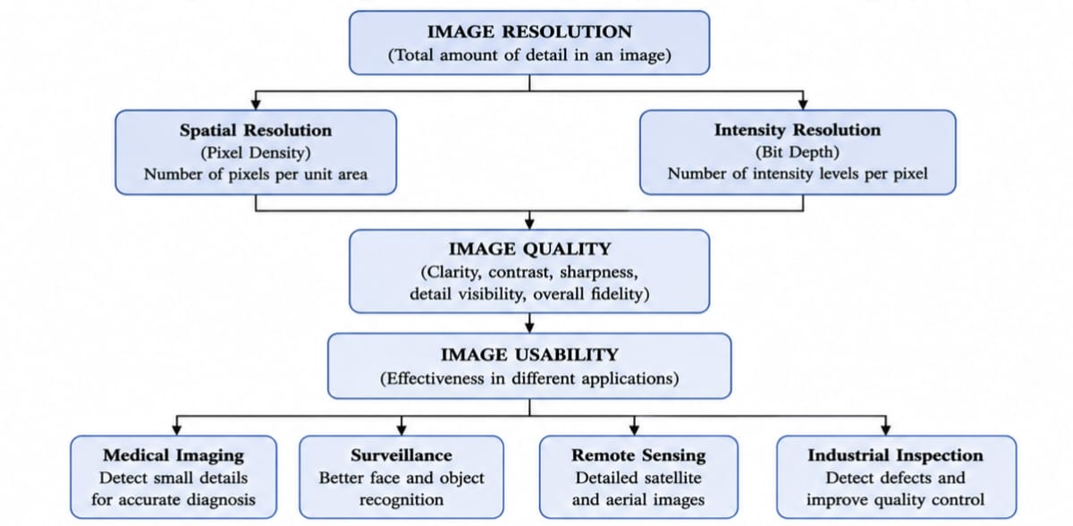
Relationship
- Image resolution depends on spatial resolution and intensity resolution.
- Higher spatial resolution provides more image details.
- Higher intensity resolution provides better brightness and contrast.
- Both together improve image quality.
- Better image quality increases image usability.
Cause and Effect
- Higher resolution → Better image quality.
- Better image quality → Accurate object detection and recognition.
- Lower resolution → Blurred images and poor analysis.
Impact on Applications
- Medical Imaging: Detects small abnormalities.
- Surveillance: Improves face and object recognition.
- Remote Sensing: Provides detailed satellite images.
- Industrial Inspection: Detects manufacturing defects.
Literature Findings (5 Sources)
- High spatial resolution improves object detection.
- High bit depth improves image contrast.
- Better image quality increases AI model accuracy.
- Medical imaging requires both high spatial and intensity resolution.
- Modern Computer Vision systems use high-resolution images for better performance.

4.Design an analytically organized concept map illustrating the factors influencing
image acquisition conditions, including illumination, sensor characteristics, motion,
environment, and optics. Show how these factors affect downstream image processing
and application performance, integrate relevant literature findings, and present the map
in a visually coherent manner.
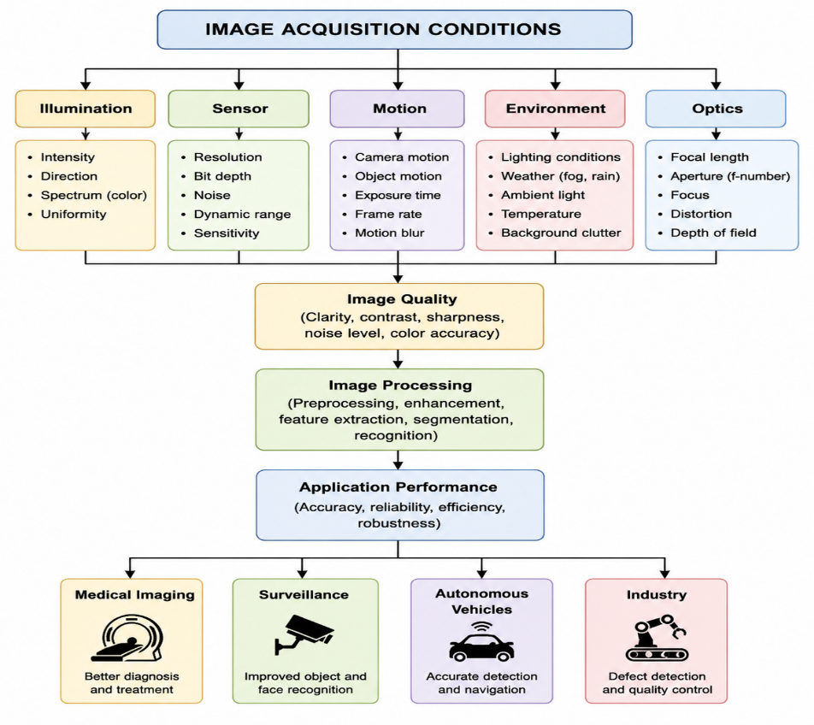
Category | Key Points
Relationship | Image acquisition depends on illumination, sensor, motion, environment, and optics. These factors determine image quality, which affects image processing and overall application performance.
Illumination | Controls brightness and contrast.
Sensor | Determines resolution and introduces noise.
Motion | Causes image blur when the camera or object moves.
Environment | Fog, rain, and dust reduce image visibility.
Optics | Lens quality affects image sharpness and focus.
Applications | Medical Imaging: Better diagnosis Surveillance: Improved face/object recognition Autonomous Vehicles: Accurate lane & obstacle detection Industrial Inspection: Better defect detection
Literature Findings | • Good lighting improves object detection.• High-quality sensors reduce image noise.• Motion compensation improves recognition accuracy.• Quality lenses produce sharper images.• Environmental enhancement techniques improve computer vision performance.

5.Construct an original concept map illustrating the relationship between Computer
Vision system capabilities and the selection of appropriate vision-based applications.
Identify major system capabilities, establish their influence on application effectiveness,
integrate perspectives from multiple literature sources, and present the concepts using
a clear hierarchical structure.
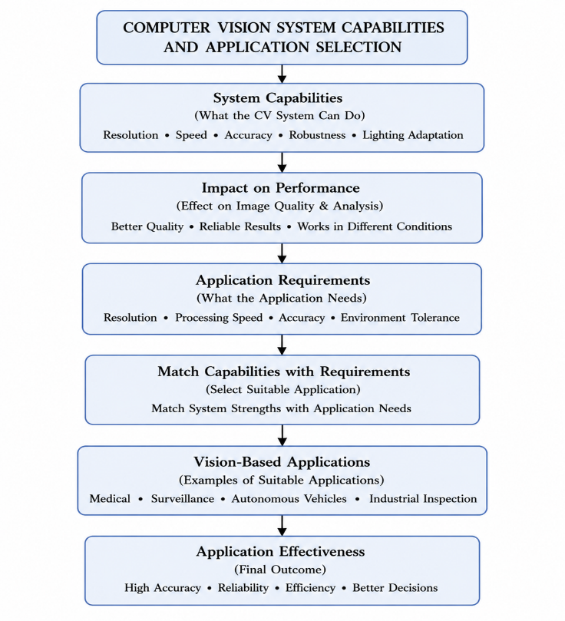

Category | Description
Relationship | Computer Vision capabilities determine the selection of suitable vision-based applications. Better capabilities improve application effectiveness and accuracy.
Major System Capabilities | Resolution, Speed, Accuracy, Robustness, Lighting Adaptation
Influence on Performance | High resolution improves image quality, high speed enables real-time processing, high accuracy provides reliable results, robustness handles different environments.
Application Requirements | Applications require appropriate resolution, processing speed, accuracy, and environmental adaptability.
Vision-Based Applications | Medical Imaging, Surveillance, Autonomous Vehicles, Industrial Inspection
Application Effectiveness | Better object detection, improved recognition, higher accuracy, reliable decision-making, increased efficiency.
Literature Findings | • High-resolution images improve feature extraction.• Real-time processing enhances autonomous systems.• Robust algorithms improve performance under varying conditions.• Accurate vision systems increase medical diagnosis reliability.• Modern Computer Vision supports intelligent automation across industries.

